Introduction
To run those examples, a Mqtt broker is mandatory (as in production mode).
We recommend to use an external broker like Mosquitto but it’s also possible to use a Node-RED mqtt broker like : node-red-contrib-mqtt-broker.

The flow
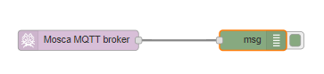
This flow has been created with node v10.16.0 and Node-RED v0.20.7.

